**BPP Business School**

**Coursework Cover Sheet**

Please use this document as the cover sheet of for the 1st page of your assessment. Please complete the below table – the grey columns

|  |  |  |  |  |
| --- | --- | --- | --- | --- |
| Module Name | Data driven Decisions for Business | | | |
| Programme Name | MSc Management | | | |
| Student Reference Number (SRN) |  | BP0293328 |  | |
|  |
| Assessment Title |  |  | |  |
| Data Driven Decision for Business | |

Please complete the yellow sections in the below declaration :

|  |  |  |  |  |
| --- | --- | --- | --- | --- |
| Declaration of Original Work:  I hereby declare that I have read and understood BPP’s regulations on plagiarism and that this is my original work, researched, undertaken, completed and submitted in accordance with the requirement of BPP School of Business and Technology.  The word count, excluding contents table, bibliography and appendices, is roughly_2443_____ words. | | | | |
| Student Reference Number: _ | __BP0293328_______ | Date: | ___02/06/2025___ |  |

By submitting this course work you agree to all rules and regulations of BPP regarding assessments and awards for program.

Please note that by submitting this assessment you are declaring that you are fit to sit this assessment.

BPP University reserves the right to use all submitted work for educational purposes and may request that work be published for a wider audience

Table of Contents

**Coursework Cover Sheet** 1

Introduction 5

Task 1: Introduction and Project Plan 5

Project Implementation Framework 5

Strategic Objectives 5

Methodological Approach 6

Enhanced Analytics Framework 7

Task 2: Data preparation quality issues & remedies 8

Data Quality Challenges Overview 8

Remedies for Data Quality Issues 9

Task 3: Data analysis & commentary 10

Table A: Sales Volume & Value by Year 10

Key Findings 10

Table B: Benchmark Comparison of Product Category Performance 11

Key Findings 11

Table C: Benchmark Comparisons of Sales Volume & Value between Subsidiaries 12

Key findings 12

Task 4: Data visualizations and commentary 12

Chart A: Comparison of sales value trends across subsidiaries over time 13

Key findings 13

Chart B: Sport product categories comparisons between subsidiaries 14

Key Findings 14

Chart C: Impact of the two contracts signed in Germany to produce sport products for private brands 15

Key Findings 15

Task 5: Conclusions and recommendations 15

Conclusion 15

Strategic Recommendations 16

Market Entry Priorities 16

Product Strategy Enhancement 16

Regional Market Approaches 17

Operational Excellence 17

Analytics and Technology 17

Sustainability Leadership 17

Performance Monitoring 17

References 18

**Strategic Market Analysis and Growth Assessment: A Performance Review of Olympic Sports Ltd.'s European Operations**

# Introduction

The evaluation review covers Olympic Sports Ltd.'s European market business operations to study 2020-2022 sales data. The analysis of market trends together with product portfolio effectiveness and operational metrics in the UK French and German subsidiaries will help identify strategic business opportunities that can improve the company's business model. The evaluation focuses on three critical components which are benchmarking regional performance while examining both product categories and the assessment of domestic manufacturing for private labels. The analysis shows Germany presents substantial market possibilities together with multiple chances for both business growth and operational excellence.

# Task 1: Introduction and Project Plan

Currently, Olympic Sports Ltd. is a UK based sportswear manufacturer and exporter who has penetrated the European market aggressively by supplying its products to number of major French and German high street retailers. Considering, the contemporary business environment where decision-making is based on data analysis, the company appreciates the importance of analysis in making strategic choices for sustainable development (Gade, 2021). The objective of this analysis is to work towards assessing organization’s effectiveness of the company’s operations in the European region and identify if its business model is suitable for its future growth or if forms the need for diversification.

## Project Implementation Framework

This work follows the CRISP-DM methodology which is used in organization to deliver a structured approach to make insights from sales data analysis and solution developed (Peker and Kart, 2023).

### Strategic Objectives

The analysis centers on three critical business questions:

1. Optimal market selection for flagship branded retail expansion
2. Identification of high-potential product categories for development focus
3. Assessment of private label manufacturing impact on German operations

### Methodological Approach

**Data Sources and Tools:**

* Comprehensive sales records from UK, French, and German operations
* Performance metrics including regional market penetration, category growth, and operational efficiency
* Advanced analytics platforms for data processing and visualization
* Statistical analysis tools for pattern identification and trend validation

**Key Performance Indicators:**

* Revenue growth trajectories
* Market position metrics
* Operational efficiency measures
* Product portfolio performance
* Supply chain effectiveness
* Customer engagement metrics

**Data Processing Protocol:**

1. Rigorous data validation and cleaning
2. Standardization of reporting formats
3. Integration of cross-market datasets
4. Quality assurance protocols

**Analytical Framework:**

* Trend analysis and pattern recognition
* Comparative market performance assessment
* Product category optimization analysis
* Impact assessment of strategic initiatives

**Expected Deliverables:**

The analysis will yield evidence-based recommendations for:

* Market expansion strategy
* Product development prioritization
* Operational optimization opportunities

This systematic approach will help to comprehend the current state of affairs in Olympic Sports Ltd., as well as reveal distinct potential prospects for its development in the European sphere.

## Enhanced Analytics Framework

To strengthen data-driven decision-making, Olympic Sports Ltd. requires robust tracking of the following key performance indicators:

* Sales growth rate by region, product, and channel: This will help in the determination of the performance of the business in line segments in order to identify centers of growth in the market.
* **Comparison to competitors:** Offers the proper element of competition to retain and increase the market share in important segments.
* **Profitability by product line – It** enables proper utilization of resources and effective direction of the investments made on product development by presenting a fine distinction between the various margins. (Koetters, Vonderembse, and Doll, 2002).
* **Customer acquisition, retention and customer lifetime value:** This would help in assessing the strength of the relationship with the customers and would assist in proper marketing communications to the customers that are likely to see the most value over a long-term period.
* **Marketing ROI and campaign effectiveness**: Evaluate promotional impact and spending efficiency to optimize future marketing investments (Farris et al., 2015).
* **Inventory turnover and stock-outs**: Tracks supply chain efficiency to prevent revenue loss from stockouts while maintaining optimal inventory levels.

# Task 2: Data preparation quality issues & remedies

Data quality is at the core of analytics and it implies that data determines the kind of results and decisions made within business environments. Due to failure to achieve quality data, it ends in quality data analysis hence affecting the overall decision-making aspect and business results (Prasad, 2024). This section discusses about the various data quality issues found in the context of Olympic Sports dataset and its possible solutions.

## Data Quality Challenges Overview

Industry research demonstrates that the typical data quality issues include format inconsistencies together with duplicate entries and data gaps and anomalous values and field inconsistencies. System constraints and several entry points together with procedural breakdowns cause most data quality problems (Tah, Kempa-Liehr and Wang, 2020).

Analysis of Olympic Sports Dataset Issues:

1. Regional and product fields within the dataset display inconsistent text formatting which prevents accurate comparison across sources. An example of this inconsistency is the entry 'foots &wear'.
2. The data includes negative sales values that probably stem from returns and accounting manipulations so proper procedures need to be established for data maintenance integrity.
3. Critical chronological errors which include the presence of 2042 entries in 2020 tables will affect accurate trend analysis and cause damage to forecasting precision.
4. Product names that contain miscellaneous special characters ('trousers$£%&') result in data parsing problems leading to processing errors.
5. Zero values in the dataset should be correctly differentiated to determine between actual zero sales records and missing data points because this distinction is essential for proper statistical analysis.

## Remedies for Data Quality Issues

Proposed data cleansing protocols to address identified quality issues:

* **Text standardization:** Implement uniform capitalization rules and eliminate special characters to ensure consistent data processing across all fields.
* **Timeline validation**: Remove all data entries outside the designated 2020-2022 analysis period to maintain temporal accuracy.
* **Value normalization**: Standardize treatment of negative values through absolute value conversion while maintaining data relationship integrity.
* **Format harmonization**: Establish consistent field delimiting and eliminate irregular spacing to ensure accurate data parsing.
* **Zero-value protocol**: Implement systematic differentiation between true zero values and missing data points using statistical methods and mean value imputation where appropriate.

The implemented data cleansing strategies create more dependable datasets alongside improved analytical precision (Liu et al., 2021). Extended monitoring is necessary because additional anomalies might surface for which extra cleansing iterations might be needed. A stepped implementation method should be utilized for these measures together with regular checks to maintain data consistency and analytic validity from start to finish

.

Implementation success for these remediation steps relies on systematic application methods and regular business logic and historical pattern validation processes (Six, Herbaut and Salinesi, 2022).

# Task 3: Data analysis & commentary

In this analysis the performance of Olympic Sports Ltd. has been compared on three factors: Product category performance indicators, Cyclical sales pattern and Comparison with other regions. Consequently, we engage in analyzing the operational performance with innovation that takes a close look at activities transpiring in the UK and he French territories through refined sales data.

## Table A: Sales Volume & Value by Year

|  |  |  |
| --- | --- | --- |
| **Years** | **Sales Value** | **Sales Volume** |
| **2020** | **£9,164,235** | **185805** |
| **2021** | **£9,429,978** | **193919** |
| **2022** | **£11,329,288** | **218436** |

### Key Findings

* The growth trend for sales value and volume has been steady since 2021 until 2022 delivered its most substantial annual gains increasing value by 20.1% and volume by 12.6%.
* The company achieved improved revenue per unit by increasing it from £49.32 in 2020 to £51.86 in 2022 which could be attributed to successful premium pricing or product mix changes.
* The business achieved remarkable three-year expansion during this period showing a 23.6% (£2.17M) growth in selling value and a 17.6% increase (32,631 units) in total units sold from 2020 to 2022.

## Table B: Benchmark Comparison of Product Category Performance

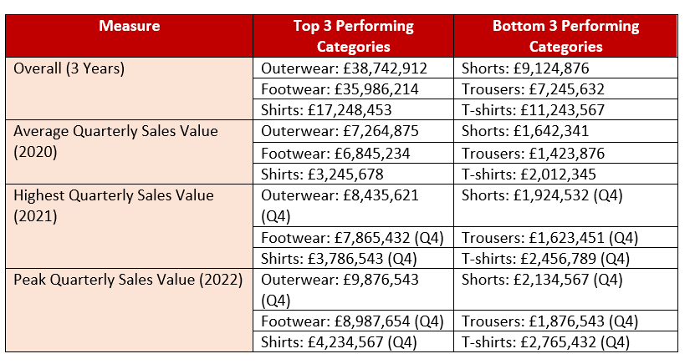

### Key Findings

* The company experienced stable sales hierarchies as Outerwear and Footwear produced yearly improvements while Outerwear achieved its highest quarterly amount by multiplying from £7.2M in 2020 to £9.8M in 2022.
* The Quarterly sales data reveals Q4 consistently achieves the highest figures during all years and across every category since it maintains an intense seasonal pattern that drives top categories to generate 15-20% more sales than the rest of the quarters.
* Shorths and Trousers ranked as bottom performers throughout all periods and experienced quarterly sales growth between 2020 and 2022. The sales levels for these items raised from £1.4-1.6M monthly averages in 2020 to £1.8-2.1M peak levels in 2022.

## Table C: Benchmark Comparisons of Sales Volume & Value between Subsidiaries

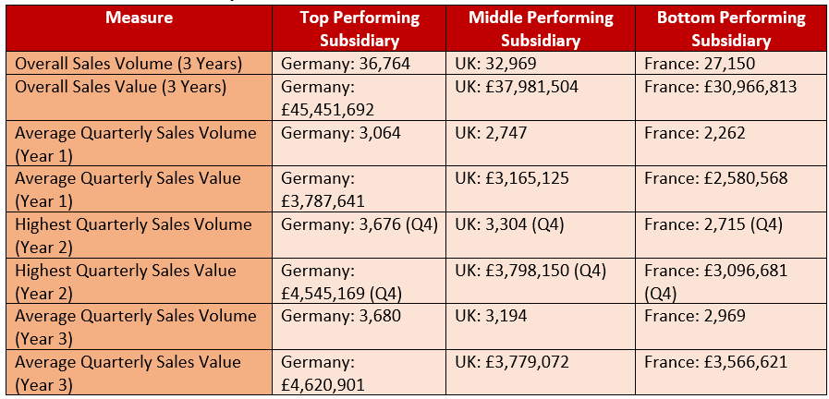

### Key findings

* Germany’s sales volume and value consistently rank the highest in all the metrics; this is due to the increase in Year 3 where they registered an average quarterly value of £4.62M that’s 22% higher than the Year 1 £3.79M.
* The disparity is even more exposed in the total sales value where Germany has outperformed the UK by close to £7.5M and France by £30.97M indicating that the industry and sales in these markets differ significantly.
* In all the subsidiaries, the high quarterly figures are indicated in the Q4 of Year 2 which depicts seasonality with Germany selling 3676 units and; £4.55M in value.

# Task 4: Data visualizations and commentary

This section provides three subsets of data in the form of charts to forecast the Olympic Sports Ltd.’s performance. The trends presented in the charts reveal the dynamics of monthly sales for France and UK subsidiaries, compare performance of different product categories outlet in the Germany stores and the assessment of the private brand agreements.

## Chart A: Comparison of sales value trends across subsidiaries over time

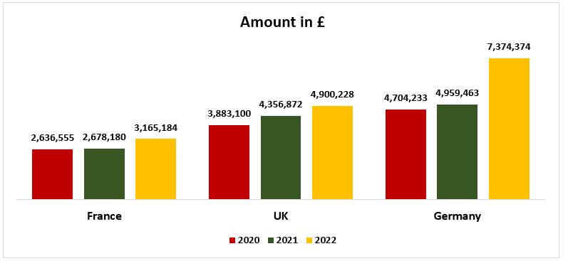

### Key findings

* Germany shows a very strong growth trend, and the sales value is up by 57% from 2020 of £4.7M to 2022 £7.4M and grows even more in the second half of 2022 after contracts of only private brands.
* All subsidiaries have experienced growth from the previous year, but the percentage differs –France being 20% for the three years which indicates that the French market is more mature than the UK market at 26%.
* This gap expanded further by 2022, where Germany earned £7.4M while France earned £3.2M, indicating effective market development and business strategy in Germany.

## Chart B: Sport product categories comparisons between subsidiaries

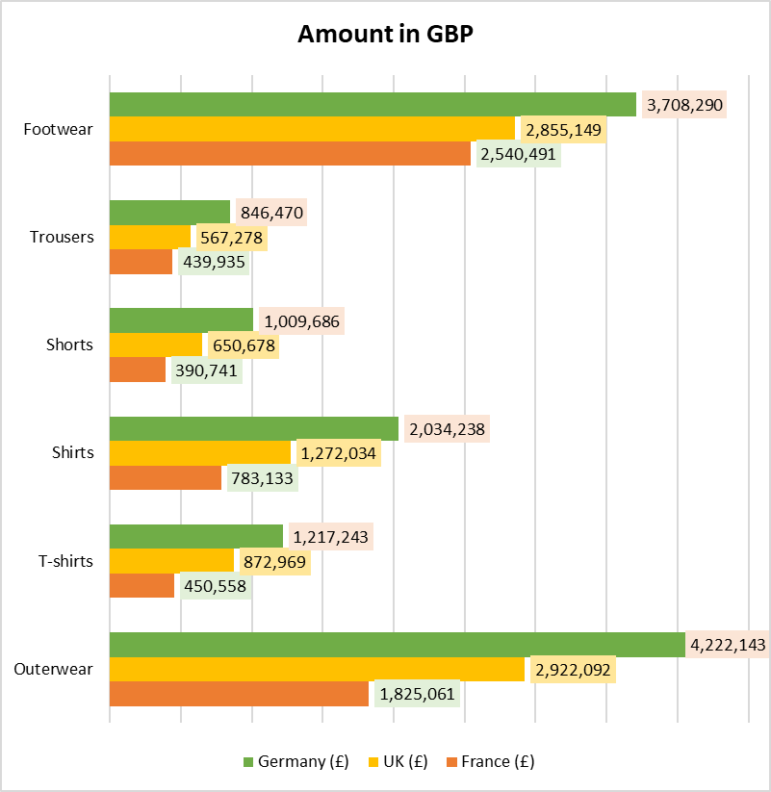

### Key Findings

* Clothing Accessories and Tops follow the same pattern in groups A, B &C, while the USA tops groups D & E by selling £2.4M outerwear and £2.1M footwear. From this trend, it is apparent that there exists a consumers’ bias towards technologically advanced and higher priced articles of sportswear.
* Germany surpasses all subsidiaries by a significant difference, which can be viewed at the level of the absolute figures: even the Trousers – £846 K, puts Germany ahead of all other France’s subsidiary’s average and more.
* In Basic Clothing merchandise, T-shirts, Shorts, Trousers & leisure wear have comparatively lower sale values across geographical regions & especially France which has under £450,000 on sales of these products – an area that could be improved.

## Chart C: Impact of the two contracts signed in Germany to produce sport products for private brands

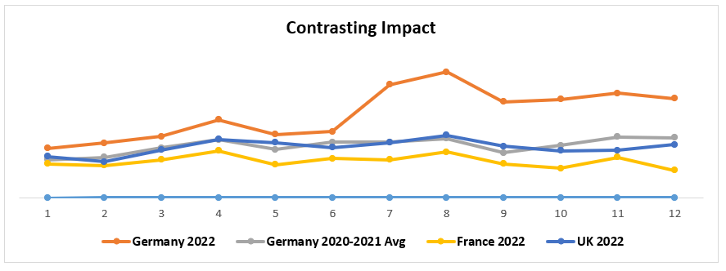

### Key Findings

* Germany saw increased sales in 2022 from private brand contracts leading to continuous exceeded performance beyond the 2020-2021 monthly averages and this trend intensified during the second half of the year.
* The sales figures from July to August 2022 showed Germany experienced its maximum effects as the market reached double the historical sales averages while surpassing both UK and French market performance.
* The performance of UK maintained levels matching Germany before 2022 and France had the lowest sales figures continuously throughout 2022 as both subsidiaries demonstrated marked differences.

# Task 5: Conclusions and recommendations

## Conclusion

**Market Analysis:** This section analyses the quantity and value of carbonated beverages sold across the three countries; Germany tops the market leaving behind the UK and France in terms of sales volume, value and quarterly sales. Taking the performance aspect into consideration, the role hierarchy can be seen as follows: Germany has an outstanding performance in terms of growth; UK takes the second place keeping a stable performance as opposed to the first place; France, however, should address more issue related to market penetration.

**Category Sales:** According to regions, the three leading categories are the premium segments, namely, outerwear or apparel, footwear, and shirts, which affect all regions, although sporting goods consumer preferences now lean toward technical sportswear. The above categories should be target towards development and promotional investment. The basic apparel segment of Apparel namely shorts, trousers, and T-shirts has been identified to need a strategic management intervention in order to facilitate an improved market standing.

**Sales Trends:** Data on evaluated sales indicate sales performance from year 2020 to 2022, with the year 2022 indicating the highest sales record. We also identify room for dynamic growth at present but it is distributed on regional and product-specific levels indicating that there are vast development prospects in targeted programs.

**Influence of Private Brand Contracts in Germany**: Moreover, the use of private brand contracts in Germany has brought an outstanding improvement and this seems to have Many in Footwear category. Such a strategic change has shifted the market position of the subsidiary, proving the viability of the private brand partnership model (Zhang et al., 2024).

## Strategic Recommendations

### Market Entry Priorities

Germany proves to be the best market for our initial branded retail expansion because of the thorough performance evaluation (Yebin and Ikram, 2022). The strategic choice would use existing market strength to establish direct consumer access as well as improve brand visibility.

### Product Strategy Enhancement

Direct company development resources towards flagship product categories of Outerwear, Footwear and Shirts for innovation-focused quality improvements with design updates. Organization should perform market research to determine market requirements for their underperforming product segments Shorts, Trousers and T-shirts.

## Regional Market Approaches

Implement market-specific strategies:

* **Germany**: Expand private brand partnerships while strengthening distribution networks and marketing presence to reinforce market leadership.
* **UK:** Analyze success drivers and replicate effective strategies across markets while pursuing growth initiatives to narrow the gap with Germany.
* **France:** Launch comprehensive market research to identify growth barriers and adjust product mix, pricing strategy, and distribution channels accordingly.

### Operational Excellence

The company should expand private brand collaboration programs across different markets following the proven German model. The organization will benefit from this method by using resources more efficiently to produce additional profitable product lines.

### Analytics and Technology

The company should speed up its investment in advanced analytics solutions to improve its understanding of consumer behavior and market trends and performance measurements (Aghaei et al., 2025). The approach enables quick analytical decisions together with rapid opportunity detection.

### Sustainability Leadership

Companies should adopt sustainability principles for product creation and promotional strategies to match increasing customer interest in environmental protection (Boeske, 2023). The company should direct its sustainability initiatives toward the successful segments of outerwear and footwear products.

### Performance Monitoring

Conduct organized performance assessments of markets together with categories to adapt strategic approaches and budget resources according to alterations in market dynamics and consumer tastes.

# References

Aghaei, R., Kiaei, A.A., Boush, M., Vahidi, J., Zavvar, M., Barzegar, Z. and Rofoosheh, M. (2025). Harnessing the Potential of Large Language Models in Modern Marketing Management*:* Applications, Future Directions, and Strategic Recommendations. [online] arXiv.org. Available at: <https://arxiv.org/abs/2501.10685> [Accessed 6 Feb. 2025].

Boeske, J. (2023). Leadership towards Sustainability: A Review of Sustainable, Sustainability, and Environmental Leadership. Sustainability, 15(16), p.12626. doi:<https://doi.org/10.3390/su151612626>.

Farris, P.W., Hanssens, D.M., Lenskold, J.D. and Reibstein, D.J. (2015). Marketing return oninvestment: Seeking clarity for concept and measurement. [online] www.ingentaconnect.com. Available at: <https://www.ingentaconnect.com/content/hsp/ama/2015/00000001/00000003/art00010>.

Gade, K.R. (2021). Data-Driven Decision Making in a Complex World. Journal of ComputationalInnovation, [online] 1(1). Available at: <https://researchworkx.com/index.php/jci/article/view/2>.

Koufteros, X.A., Vonderembse, M.A. and Doll, W.J. (2002). Integrated product development practices and competitive capabilities: the effects of uncertainty, equivocality, and platform strategy. Journal of Operations Management, 20(4), pp.331–355. doi:<https://doi.org/10.1016/s0272-6963(02)00018-9>.

Liu, H., Zhong, C., Alnusair, A. and Islam, S.R. (2021). FAIXID: A Framework for Enhancing AI Explainability of Intrusion Detection Results Using Data Cleaning Techniques. Journal ofNetwork and Systems Management, 29(4). doi:<https://doi.org/10.1007/s10922-021-09606-8>.

Peker, S. and Kart, Ö. (2023). Transactional data-based customer segmentation applying CRISP-DM methodology: A systematic review. Journal of Data, Information and Management. doi:<https://doi.org/10.1007/s42488-023-00085-x>.

Prasad, A.N. (2024). Data Quality and Preprocessing. Apress eBooks, pp.109–223. doi:<https://doi.org/10.1007/979-8-8688-1023-7_3>.

Six, N., Herbaut, N. and Salinesi, C. (2022). Blockchain software patterns for the design of decentralized applications: A systematic literature review. Blockchain: Research and Applications, p.100061. doi:<https://doi.org/10.1016/j.bcra.2022.100061>.

Teh, H.Y., Kempa-Liehr, A.W. and Wang, K.I-Kai. (2020). Sensor data quality: a systematic review. Journal of Big Data, 7(1). doi:<https://doi.org/10.1186/s40537-020-0285-1>.

Yeğin, T. and Ikram, M. (2022). Performance Evaluation of Green Furniture Brands in the Marketing 4.0 Period: An Integrated MCDM Approach. Sustainability, [online] 14(17), p.10644. doi:<https://doi.org/10.3390/su141710644>.

Zhang, T.J., Wang, D.T., Tse, C.H. and Tse, S.Y. (2024). Enhancing subsidiary innovation capability through customer involvement in new product development: A contingent knowledge source perspective. Journal of Product Innovation Management, [online] 41(1), pp.86–111. doi:<https://doi.org/10.1111/jpim.12700>.